3.1 Software

3.1.1 Features
The project team applied the User Story Mapping approach to derive the actual software features required to satisfy user needs. The following table summarizes the mapping between user stories and the corresponding system features:
User Story | Software Feature
As a new user, I want to register an account so that I can participate in solving programming problems. | User Account Registration
As a registered user, I want to log in so that I can access problem sets and view my submission history. | User Login & Authentication
As a user, I want to view problem lists categorized by difficulty (Easy, Medium, Hard) so that I can select suitable problems. | Problem Browsing & Difficulty Filtering
As a user, I want to write code directly on the website and run it to see the results. | Online Code Editor & Code Execution
As a user, I want to see the execution results (correct/incorrect, runtime, errors) so that I know if my solution is correct. | Automatic Judging & Result Feedback
As a user, I want to view the history of submissions and the result of each attempt to track my learning progress. | Submission History & Progress Tracking
As a user, I want the code judging to respond within 10 seconds so that I do not have to wait too long. | High Performance Response Time (≤ 10s)
As a registered user, I want my password to be protected and not easily guessed. | Security & Password Hashing
As an administrator, I want to create, update, and delete problems to maintain and update the system content. | Admin Panel for Problem Management
As an administrator, I want to view the number of users and the statistics of submissions over time. | System Analytics & User Activity Statistics

3.1.2 Software Architecture
The software system follows a Client–Server architecture combined with asynchronous job processing for running and judging user code. The high-level architecture is illustrated as follows:
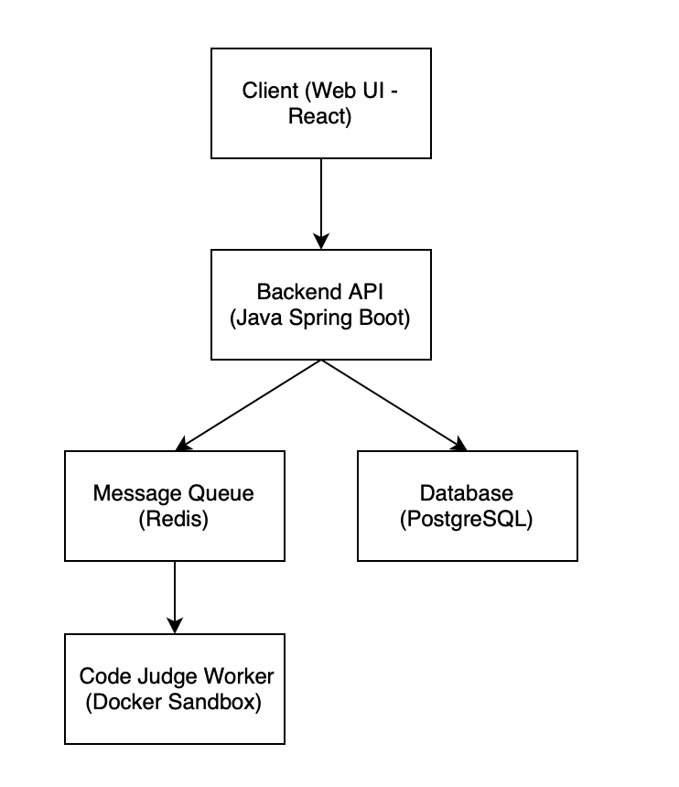
Main components:
- Frontend Web (React): provides user interface for problem browsing, code editing, and submission.
- Backend API (Java Spring Boot): handles authentication, business logic, problem management, and submission processing. Spring Boot was selected to better support enterprise-grade development practices and layered architecture.
- PostgreSQL Database: stores users, problem metadata, test cases, and submission history.
- Redis Queue: acts as a message broker to queue submissions and support non-blocking code execution.
- Docker Judge Worker (Python): executes user-submitted code inside isolated containers, evaluates correctness, and returns the result to the backend.

3.2 Hardware

3.2.1 Hardware Requirements
In order to run all software components (Frontend, Backend API, Database, Redis Queue, and Code Execution Worker), the system requires a computing environment with the following minimum specification:
Hardware Component | Minimum Requirement
CPU | 2 cores
RAM | 8 GB
Storage | at least 50 GB available
Operating System | Windows / Linux / macOS (Ubuntu recommended for worker execution)
A machine with the above specification is sufficient to run the full system locally for implementation, testing, and demonstration purposes.

3.2.2 Required Equipment for Operation
The following equipment is required to operate the system and demonstrate it during the project presentation:
Equipment | Purpose
Personal laptops (each group member) | Used for software development and local testing
One dedicated laptop (acting as local server) | Runs Backend API, PostgreSQL, Redis Queue, and Code Execution Worker
Internal Wi-Fi Router (LAN network) | Allows other devices to access the system during the live demo
Classroom projector / display screen | Used to present and demonstrate the system to the instructor and evaluators

